C
AWANUI SCHOOL STRATEGIC PLAN
2023 - 2025

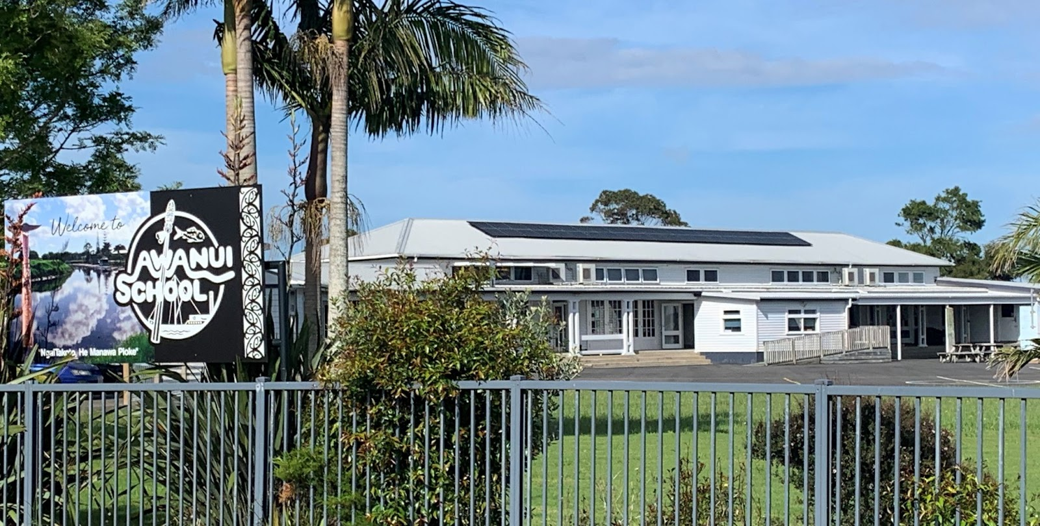

“Na te whainga teitei ka taea.”
“Through high endeavour achieve.”

AWANUI SCHOOL
Ko Kurahaupo te waka
Ko Tohoraha, Ko Puwheke, Ko Te Rangianiwaniwa nga maunga
Ko Rangaunu te moana
Ko Tuwhakatere ratou ko Tuterangi-a-Tohia, ko Tupaia nga tangata
Ko Ngai Takoto te iwi

OUR VALUES

OUR BIG GOALS – WHAT IS IMPORTANT FOR US?
- To ensure the Hauora of everyone at our school is cared for.
- All students are encouraged and supported to achieve to the best of their ability.
- To make our school so awesome everybody wants to be here.

OUR LOCAL CURRICULUM

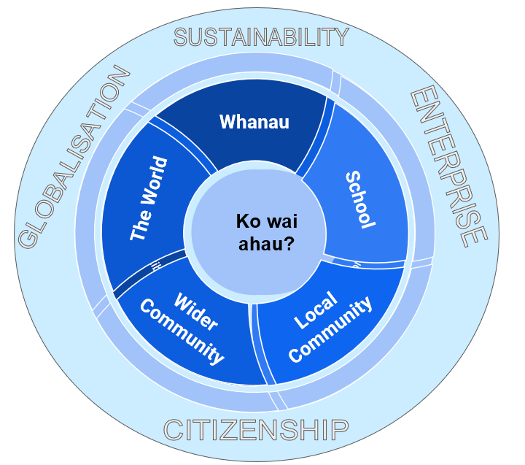

3 YEAR STRATEGIC OVERVIEW
 | 2023 | 2024 | 2025
To ensure the hauora of everyone at our school is cared for. | - Whare Tapa Wha – (focus on Hinengaro and Wairua)  - Use of outside agencies (Kaihapai o te Kura, School Counsellor, RTLB,).  - Ka Ora Ka Ako programme – Kai for our kids.  - Board act as good employers by ensuring the well-being of all staff are cared for.  - Staff have professional opportunities to improve their practice.  - Review of teaching as inquiry model. | -  - review effectiveness of agency support.
All students are encouraged and supported to achieve to the best of their ability. | - Culturally responsive practice:  - Māori learning as Māori and achieving as Māori  - Commitment of staff to improve their understanding and use of Te Reo Māori  - By the end of the year both classes will be delivering Te Reo Maori at a minimum level of 4b (5 hours per week).  - Kapa Haka  - Review of assessment practices for writing.  - participation in BSL programme  - investigate strengths-based reporting and measurement  - Provide equitable opportunities (special learning and support)  - look at ways we can better engage whanau in their children’s learning.  - Regular monitoring and reporting of progress to Board and whanau | - By the end of the year both classes will be delivering Te Reo Maori at a minimum level of 4a 12%–30% of the total time, i.e. for more than three and up to 7.5 hours per week (more than 70% of instruction is in English  -  - continuation of BSL | - consolidate delivery of Te Reo Maori at Level 4a or higher.  - review effectiveness of BSL
To make our school so awesome everybody wants to be here. | - Monitoring attendance – identify a cohort group to monitor over time.  - Celebrating successes  - Providing a variety of exciting opportunities for our kids – visitors to school, trips (STEM PLD) – participation in sporting events.  - Ensure our school grounds and buildings are safe and look c  - Make our school environment is a safe place.  - to show that our school is an inviting attractive place to be.  - investigate and get quotes for:  - Upgrade to areas of the playground.  - The water system for the school.  - Repairs to the swimming pool  - begin replacing classroom furniture  Kaitiakitanga:  Decide on a name for the project/area  Plan/Begin restoration project of the back field to create a native plant and creature area. The area to be given a special name.  Incorporate into our teaching and learning. | Continue monitoring group – report to board mid and end of year.  -  - development of area – identify next steps and opportunities for funding | - Maintenance of area  - develop a plan for future development.

2023 ANNUAL PLAN
All students are encouraged and supported to achieve to the best of their ability.
FOCUS | HOW IT WILL BE ACHIEVED | EVIDENCE | OUTCOMES
Culturally responsive pedagogy – Maori learning as Maori | - reflect on PLD from the previous year.  - articulate what this looks like in this school.  - identify aspects of our practice where we can improve.
Provide equitable opportunities | - all children will have access to quality resources  - continue with Reading Recovery  - Tracey and Leah to take part in Better Start Literacy Approach PLD.  -
Strengthening our partnership with whanau and wider community. | - social media  - attending local meetings (marae and Awanui Ratepayers).
Involving whanau in their child’s learning. | - take all opportunities both formal and informal to involve whanau  - whanau hui in term 2
Review of assessment practices. | - a major focus for the year will be a review of our assessment practices.  - are they effective? Are they culturally appropriate? Do our children know what is expected of them? Do our whanau understand what assessment is and what it looks like?  - review of writing assessment / CaAP / exemplars / matrices / resources  - begin investigating strength-based reporting and measuring
Ensure Staff have professional opportunities to improve their practice. | - Commitment of Staff to improve their use and understanding of te reo.  - look at Maori language courses available.  - Participation in Better Start Literacy Programme – Leah / Tracey / Sue Stanaway RTLB
Review teaching as inquiry model to ensure it meets our needs | - to review our teaching as inquiry model to ensure it is more robust.  - to make sure we cover changes in the NZ curriculum  - to ensure it meets the needs of our children and leads to improved practice.
Local curriculum | - Ko wai au? Understanding our place in the school and wider community  - Visit to Waimanoni Marae in term 1/2.  - Visit to the pou that have been carved in our rohe and hear the stories behind their creation.  - Who do we have in the community that can tell us the stories / history?  - Links to NZ Histories curriculum

2023 ANNUAL PLAN
To ensure the Hauora of everyone at our school is cared for.
FOCUS | HOW IT WILL ACHIEVED | EVIDENCE | OUTCOMES
Whare Tapa Wha | - refresh on the Whare Tapa Wha model – to include the 5th dimension of Whenua.  - focus on Hinengaro and Wairua.  - incorporate it into our learning and goal setting.
Use of outside agencies to support (Kaihapai o te Kura, School Counsellor, RTLB). | - ensure all children and whanau have access to agencies to support learning and wellbeing.  -
Ka Ora Ka Ako programme – Kai for our kids. | - to continue providing healthy lunches according to the guidelines and within budget.  - students to have input into menu planning.  - keep whanau informed of menus
Continue to strengthen the partnership with our whanau. | - continue to offer support wherever we can  - keep whanau fully informed on all aspects of school life.  - ensure whanau are informed on a more regular basis of their child’s progress or lack of. How can we do this?  - board to develop a system – each board member has a group of whanau they make contact with for school matters or on a more informal basis – perhaps via messenger
Board to act as good employers be ensuring staff well-being is cared for. | - board members to “keep in touch” with staff on a more regular basis.  - board to keep informed of obligations as employers
Continue with Healthy Active Learning programme. | - look for opportunities to extend our “Take a Risk” programme in the local area.  - provide regular physical activity  - implement planning and programme overview from facilitator.

2023 ANNUAL PLAN
To make our school so awesome everyone wants to be here.
FOCUS | HOW IT WILL BE ACHIEVED | EVIDENCE | OUTCOMES
Monitoring attendance | - set challenging but realistic targets for student attendance.  - identify links between attendance and achievement. To track a cohort group.  - provide incentives for attendance.  - encourage intrinsic motivation – they want to be at school!  - report attendance rates to Board each term  - celebrate at assembly, newsletters, Facebook
Celebrating successes | - using platforms such as Facebook to share our successes  - newsletters and personal contact with whanau
Providing a variety of exciting opportunities for our kids | - day trips to enhance and support curriculum learning.  - visiting facilitators from STEM – term 1 – CSI Forensic team and Spaceward Bound team.  - other opportunities including sport as they arise.  -
Care for our environment  Kaitiakitanga | - working through the local curriculum to plant a native area in our school – become Kaitiaki of our school.  - ensure there is a budget for this initiative  - seek funding for the initiative and support people within our community who can help.
Make our school attractive and inviting | - begin plans for the next 5YA / 10YPP  - invest school funds into improving our playground and making it safe.  - follow up with ministry on the rationalisation of Room 5 and 6 (this is the removal of both buildings). Contact person Melanie Sweet.
Ensure our school is a safe place for everyone | - review our Health and Safety practices to ensure we meet the requirements.  - meeting in term 2 to develop an annual plan to ensure all areas are covered and roles and responsibilities are clearly understood.
Quality resources and equipment | - begin purchase of new furniture for classrooms.  - grants to be applied for each term for extra sports equipment, chrome books, Ipads etc.

STUDENT ACHIEVEMENT TARGET – 2023
Background:  . assessment of writing is always a challenge and there is no easy way to do this.  - we often think we mark too hard and our children are often better writers than we think.  - we use exemplars and our school CAaP to assess writing.  - Curriculum Level 3 within and at is the most difficult to reach.  - ALL has been done in previous years with mixed results.  - aspects of ALL are still practiced in the classrooms.  - we will be a buddy school with Pukepoto to share ideas and cross moderate children’s writing. | Achievement Target:  Year 3 – to be achieving at Level 2W or higher.  KM (Y5) to be working At Level 3.  DDD and PW (Y5) to be working Within Level 3.  HC and SHD (Y4) to be working At Level 2 or higher.  TJ (Y4) to be working Within Level 3.
ACTIONS TO BE TAKEN |  | WHO
In 2023 we will undergo a review of our teaching and assessment practices for writing.
Resources will be collated and the different writing assessments available will be looked at (e-Asttle – exemplars). The Principal to lead this review.
Shared folder set up for resources and exemplars. Begin with a review of what we have already and set up a shared folder that can be regularly updated. |  | Principal
Identify target children – (see above) – this will include children to accelerate. |  | All staff.
Review of CaAP for writing – ensure it meets our needs and is a workable document. |  | All staff
Work with Pukepoto School to cross moderate writing and share ideas. They are a small school like ours with similar needs and aspirations. |  | All staff and Principal to organise.
Review how and when we collect writing samples. Have the process recorded as part of the CaAP. |  | All staff.

